May 29, 2009

---------------------------------------------------------------------------------------------------------------------------------

Delhi is reeling under high levels of deadly ozone, says latest CSE analysis

---------------------------------------------------------------------------------------------------------------------------------

- In April, ozone levels exceeded the standards proposed by the Union ministry of environment and forests. Peak levels have been unusually high – indicates an analysis by Centre for Science and Environment (CSE)
- This is a result of a combination of an intensely hot summer with high levels of vehicular pollution in the city
- Ozone can kill and make people seriously ill if it increases even for a short duration during the day
- Despite the obvious fallout, the Union government is delaying notification of its draft standards for ozone and other critical pollutants. Cities like Delhi need to act fast to reduce the cocktail of gases that form ozone in the air

---------------------------------------------------------------------------------------------------------------------------------

New Delhi May 29, 2009: Delhi has been witnessing an unprecedented ozone build-up this summer, says a latest analysis done by Centre for Science and Environment (CSE). Nearly every day in the month of April, ozone levels have exceeded the standards proposed by the Union ministry of environment and forests (these standards are yet to be notified).

Ozone is known to be extremely hazardous for human health. According to the researchers behind this analysis, the ozone build-up is the result of a deadly combination of high pollution levels and an unusually hot and sunny summer.

According to Anumita Roychowdhury, associate director, CSE and head of the Centre’s air pollution unit, “ozone is not emitted directly from any source. Other pollutants, primarily nitrogen oxides (NOx) and hydrocarbons that are spewed by the growing number of vehicles and other sources in the city, react in the atmosphere under the influence of sunlight and high temperature to form ozone.”

“When ambient temperatures and sunlight remain high for several days -- as it has happened this summer -- and the air is relatively stagnant, ozone builds up fast,” she adds.

What has CSE found?

CSE has analysed ozone data generated by the Central Pollution Control Board in its three automatic monitoring stations in Delhi – Siri Fort, the ITO traffic intersection and the Delhi College of Engineering (DCE) in Bawana -- from January till May 17, 2009.

The data has been assessed in relation to the proposed ozone standards in India. There is a wide variation across the months, but a clear pattern is easily discernible. The CSE analysis throws up the following scary facts:

- More frequent violation of ozone standards as the temperature rises: The number of days violating the upcoming standards of 90 microgramme per cubic meter (for a daily maximum eight-hourly average), have steadily increased since cold January and exploded during the hot summer months. In January, the ozone level exceeded only on 4 per cent of the days monitored. By April, nearly all days at DCE and ITO show violation of standards – 95 per cent of days in DCE and 81 per cent in ITO. The levels at ITO have been particularly high during May 1-9 – ranging between 120 microgramme per cubic meter and 192 microgramme per cubic meter. This clearly coincides with the trend in ambient temperature that increased to uncommonly high levels this summer.
- Peak ozone levels have been unusually high: Normally, ozone levels are expected to be comparatively higher during summers – this year, uncommonly high peaks have been recorded. The maximum level in Siri Fort has scaled to 199 microgramme per cubic meter on March 22. At ITO, the value of ozone on May 1 hit as high as 192 microgramme per cubic meter.
- Outskirts of Delhi bear the brunt of the pollution in the city: Usually, ozone is known to form in city centres and then drift to the periphery. Bawana, one of the monitoring locations in the northern peripheral limits of urban Delhi, has been earmarked as a residential area by the apex monitoring body. It has shown very high levels of ozone, particularly in the months of February, April and May. The values in February have exceeded the safe limits almost on every second day, while in April, they have touched a high of 188 microgramme per cubic meter (see graph below).

Graph: City centre and outskirts are equally vulnerable

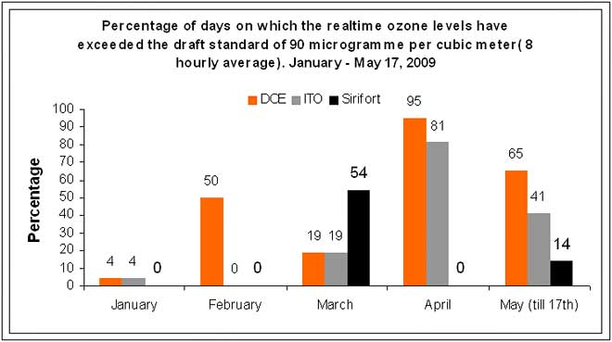

Source: Computed from data generated by the Central Pollution Control Board

Why should we be worried about ozone?

Ozone is an extremely harmful substance: just a few hours of exposure to it can trigger serious health problems. It worsens symptoms of asthma, leads to lung function impairment and damages lung tissues. Chest pain, coughing, nausea, headaches and chest congestion are common symptoms. It can even worsen heart disease, bronchitis and emphysema. It increases emergency medicare visits and hospital admissions related to respiratory diseases.

Scientists inform that ozone is a powerful oxidizer, which means it can damage cells in a process akin to rusting. Children and the elderly are at special risk. International studies have also found a strong association between ozone and daily premature death counts; deaths related to ozone exposure are more likely among people with pre-existing diseases.

Ozone is included in the daily smog and health alert programmes in countries such as Mexico and the US. In Mexico City, the elderly, children and those suffering from respiratory and cardiac problems are advised to stay indoors when levels of ozone go up. The US-based National Research Council, part of the National Academies of Science, has recommended that local health authorities should keep the harmful effects of ozone in mind when advising people to stay indoors on polluted days.

What should Delhi do?

With the upcoming Commonwealth Games, Delhi will have to be even more careful as athletes are more vulnerable to air pollution -- especially to ozone pollution. Reports show that with every breath, athletes typically take in 10 to 20 times as much air, and thus pollutants, as sedentary people do.

A study carried out in the US, led by the University of Southern California and reported in the Lancet, has found that in high-ozone areas the relative risk of developing asthma in children playing three or more sports was more compared to children playing no sports.

“Delhi must act immediately,” says Roychowdhury. “Urgent steps are needed to control pollutants that help form ozone in the air.” The CSE analysis recommends the following:

- The Union ministry of environment and forests must notify its proposed air quality standards without delay to help city governments implement control strategies for ozone-forming gases.
- The city government must prevent an increase in ozone levels by making serious efforts to control the emissions of NOx and volatile organic compounds that largely come from vehicles.
- NOx reduction strategy must prevent explosion in numbers of diesel cars and SUVs as advanced emissions control technologies and clean diesel fuel are not available in India. Diesel vehicles emit three times more NOx than a petrol vehicle.
- The city government must introduce a daily health alert system to inform the sensitive population (children, elderly and those suffering from respiratory and cardiac problems) about the high daily levels and enforce emergency pollution control measures such as restricting traffic, and allowing only clean fuel and vehicles and public transport in affected areas till the levels dissipate.

Resources:

- For more on this, you can get in touch with Anumita Roychoudhury of CSE at anumita@cseindia.org or on 98117 93923.
- For more on this, you can get in touch with Jayeeta Sen of CSE at jayeeta@cseindia.org or on 9910035154.
- To access more CSE resources on the subject of ozone and air pollution, just write to or speak with Shachi Chaturvedi of CSE’s Media Resource Centre on shachi@cseindia.org / 98187 50007.
- You can also contact Dr J S Kamyotra, member secretary, Central Pollution Control Board, Delhi on jskamyotra.cpcb@nic.in or 011-22303655

